

MYSQL DB Maintenance Activity

**Document Information**

|  |  |  |  |  |  |
| --- | --- | --- | --- | --- | --- |
| **S.No** | **Version No.** | **Prepared By** | **Approved By** | **Date & Month** | **Description** |
| **1** | **0.1** | **Shanmuga Priyan** |  | **19.04.2020** | **Draft version** |
| **2** | **1.0** | **Sudherson** |  | **23.04.2020** | **Initial version** |

|  |  |
| --- | --- |
| **Document Name: SOP For MYSQL DB Maintenance activity in SA Linux Servers** | |
| **Project:** TVS & Sons | |
| **Subject:** DB Maintenance Activity | |
| **Document No.:** TVS-GCP-001 | **Version:** 1.0 |
| **Prepared by:** Shanmuga Priyan, 1Cloudhub | **Date:** 23 Apr 2020 |
| **Reviewed by:** Karthik Palani, 1CloudHub | **Date:** 25 Apr 2020 |
| **Reviewed by:** Vijaykumar, TVS | **Date:** 29 Apr 2020 |

**Table of Contents**

**Purpose:** 3

**Responsibility:** 3

**Steps to Perform the activity:** 3

# **Purpose:**

The Purpose of this document is to perform monthly MYSQL DB maintenance activity in SA Linux servers.

## **Responsibility:**

1CH team is responsible for performing Monthly MYSQL DB maintenance activity in the SA Linux servers by following the below mentioned steps and ensuring the server functionality.

### **Steps to Perform the activity:**

**Step 1:** Need to take the backup of the existing Databases.

For that please login to the server and then login to the MYSQL database by using the following command.

**“mysql -u ‘username’ -p** and then press enter, it will prompt for the password. (use the respective password)

Once logged in to the database type the command ‘show databases;’ to list the current database, copy all the database names to the notepad.

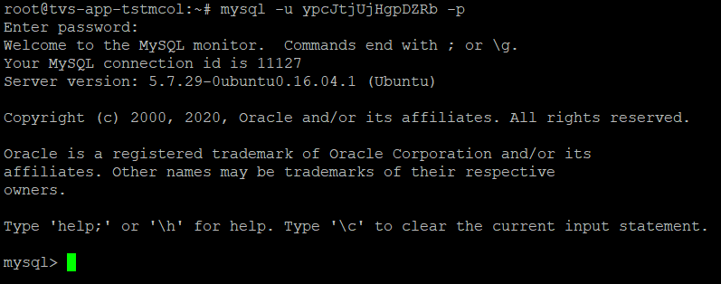

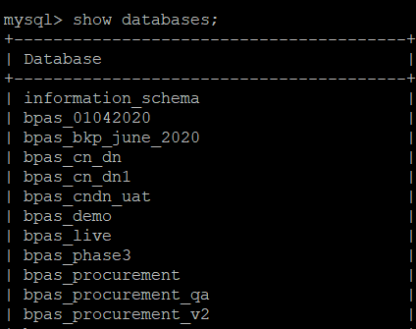

**Step 2:** Create a folder called DBbackup in any directory. To create a folder use the command

**‘mkdir foldername’**

**Note:** For all the servers we have already created backup folders in the below locations.

**TVS-APP-MCOL1 – /data/backup/**

**TVS-APP-SPRT -- /data/backup/**

**TVS-APP-MOTOLOG -- /home/backup/**

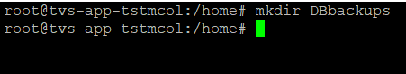

**Step 3:** To take the database backup, use the below command.

**mysqldump -u ‘username’ -p ‘dbname.sql’ > folder location ‘dbname.sql’**

**mysqldump -u root -p renaultm_motolog.sql > /home/backup/renaultm_motolog.sql**

**Note: Before taking backup, Kindly clear the old backup files.**

**Step 4:** Once back up are taken kindly run the check commands for each databases as a part of maintenance.

mysqlcheck -c ‘dbname’ -u ‘username’ -p **(It will prompt for password, kindly enter the password accordingly)**

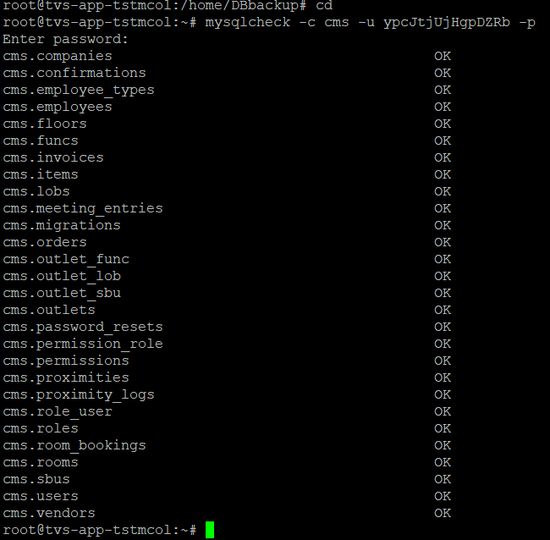**.**

**Step 5:** Once check commands are completed, run analyse command for each database as a part of maintenance.

mysqlcheck -a ‘dbname’ -u ‘username’ -p **(It will prompt for password, kindly enter the password accordingly)**

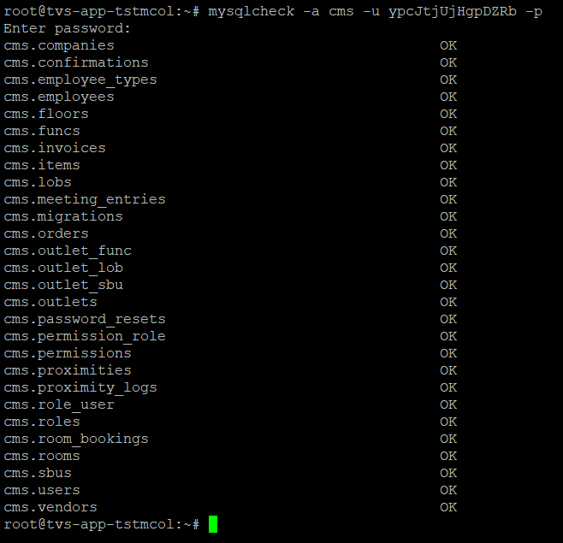

**Step 6: Finally execute the optimization command for each database.**

mysqlcheck -o ‘dbname’ -u ‘username’ -p **(It will prompt for password, kindly enter the password accordingly)**

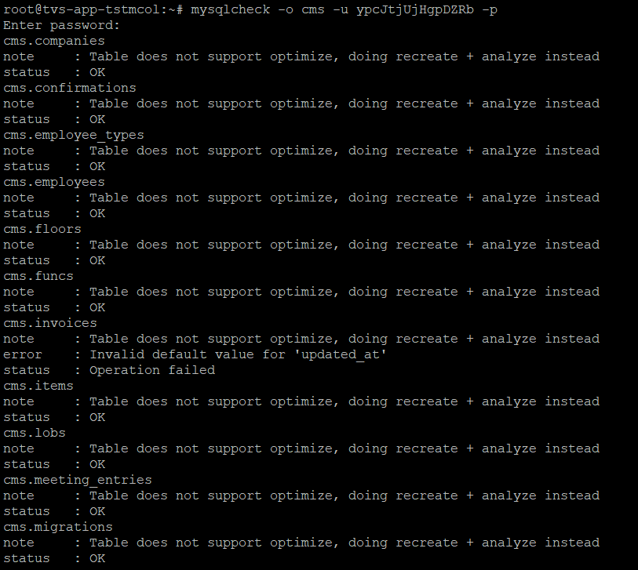

**Note: All the status should be in OK, if any table shows error, note that table name and login in to the MYSQL as mentioned in Step 1 and run the below command for affected table.**

**Repair table ‘table name’**